
Motor/Propeller Test Set
Documentation
April 17, 2011

This is a working document to describe the Motor/Propeller Test Set (M/PTS).

Purpose:
A Device to fully test a combination of a Motor and Propeller to characterize COTS items for optimal selection and definition for the ICARUS Vehicle.

Description:
This device mounts a motor/propeller to be tested on a linkage that has a variety of sensors attached. When testing begins, an automated test program executes through a personal computer where all data is logged and after testing analysis can be performed.

Requirements

Requirement | Target | Goal
Measurements | Current, Force | Current, Force, Temperature, Rotation Speed
Run-Time | 20 min | 1 hr
Storage Format | Line | XML
Timing | Host-based | RTC
Power Source | Batteries, ICARUS Vehicle Battery | Line, ICARUS Vehicle Battery
Test Items – Motors | Brushless, Outrunner | Brushless, Outrunner or Inrunner; Brushed
Test Items – Propellers | 12” | 14”
Sampling Frequency | 50 Hz | 500 Hz
Cost | $250 | $150

Requirement Description

Measurements
The M/PTS should be able to measure different parameters while a Test is being performed. This will aid in the analysis of the COTS items that are being tested. At a minimum, Electric Current and Force should be measured. Propeller Rotation speed and Temperature should also be measured.

Run-Time
The M/PTS should be able to run COTS items for an extended duration of time. This will aid in the characterization of how long the COTS item may be ran onboard an Aircraft. The Target, 20 minutes is the expected maximum flight duration of the ICARUS Vehicle. The Goal, 1 hr is the continuous flight duration of the ICARUS Vehicle while being used on the ICARUS Test-Stand.

Storage Format
The Test Data should be stored, either on the M/PTS or on the Host Computer. The data format should be defined to aid in Analysis.

Timing
The Test Data should be

Power Source
The M/PTS should be capable of running COTS items for extended periods of time. Due to the high current draw of a Brushless motor batteries may be the only option that satisfy the cost requirement, but may not be able to meet the Run-time requirement. An affordable option using Line power would be the preferred method. Additionally, the ICARUS Vehicle Battery should be able to be used on the M/PTS as well for different analysis requirements.

Test Items – Motors
The M/PTS should be able to at least test Brushless Outrunner Motors, as they are the intended motor for the ICARUS Vehicle. Ideally it would also be able to test any Brushless or Brushed motor, although the required speed controller would have to be changed.

Test Items – Propellers
The M/PTS should be able to test a variety of different size Propellers, including up to a diameter of 12”. Additionally, for future development of ICARUS the M/PTS should be able to test Propellers up to a diameter of 14”.

Sampling Frequency

Cost

Authorizations
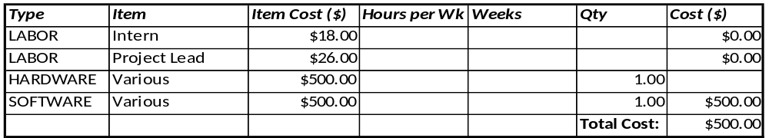

Sub-Systems
Frame
Power
Control
Measurement

Control

Measurement
Force
http://www.sparkfun.com/products/8712
Current
http://www.sparkfun.com/products/9028
Temperature
Rotation Speed

